**Pyber Analysis for Weekly Fares by City Type**

Using Pyber data, ride share information for fares, ride count, and driver totals were grouped by city type to identify stories related to different city types for rural, suburban, and urban areas. Data analysis process utilized disciplines from python, pandas, and matplotlib to extract, transform, and visualize key information a 4-month period of 1.1.2019 – 4.29.2019 set on a weekly datetime basis.

During the start of the analysis, we identified the Total Rides, Total Drivers, Total Fares, Average Fare per Ride, and Average Fare per Driver by city type categories (**Figure 1**). Rural areas had the smallest number of rides, lowest number of drivers, but had the highest average fare per ride as well as the highest average fare per driver. On the opposite spectrum, Urban city types had the largest number of rides, highest number of drivers, but had the lowest cost for average fare per ride as well as average fare per driver. Suburban city types were in the middle between the two. There is a indirect relationship between Total Rides and Drivers to Average Fare per Ride and by Driver as when there are more rides needed and available drivers in an area for Pyber use, the cost for the fare by the consumer and revenue collected are inversely related. This held true consistently as having more available drivers for available rides provided a more economical price point for end users/consumers. By dividing total rides by total drivers, an average of rides by driver can be calculated with Rural at the highest (1.60), Suburban in the middle (1.28), and Urban at the lowest (0.68) which also supports the indirect correlation.

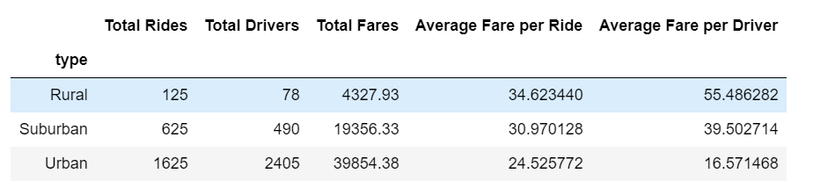

**Figure 1: Summary by City Type**

By further transforming the raw data source into DateWeek and by week categorizations, we identified further trends for rides and fare costs by city type (**Figure 2**). With ride volume count, Urban areas provided higher sums/revenue from Pyber customers, Suburban in the middle, and Rural at the bottom. Trends over the 4 month period captured the 4th week of February to have the highest rides and fare revenues across all city types. The month of April was irregular for Suburban city types with a dramatic steady velocity increasing in usage whereas both Urban and Rural fares showcased a negative velocity in revenue. Overall revenue trends by week varied across different city types with low and high peaks, but were somewhat consistent.

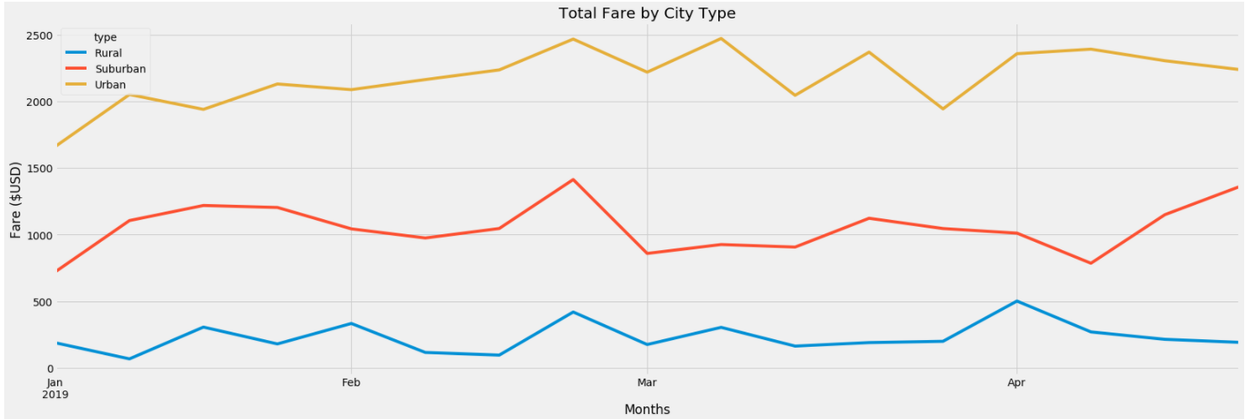

**Figure 2: Fare trends by weeks by city type**

In conclusion, there are 3 recommendation after analyzing city and rider data to take into action from historical data to provide better UX (user experience) and to provide steady, if not greater revenue for Pyber for our NOI (Net Operating Income) and P&L (Profit and Loss). 1) Total Rides and Total Driver averages need to be reviewed as Pyber has too many drivers in Rural areas, and too few drivers in Urban areas. By capturing the middle average to resonate with Suburban models, this provides less waste in contractors/Full Time Employees (drivers) and provides opportunities for more revenue for drivers and a lower cost for consumers (riders). This will impact both NOI and P&L for less waste in overhead. 2) We need to offer loyalty or concessions to rural areas to get more onboarding on the platform and brand loyalty to remove any competitors. Suggest running a market survey analysis on competitor data on these city types and fares to ensure that we are staying competitive as April is showing steady decline in Urban and Rural areas. 3) Review costs of fares for Rural areas as they are significantly higher than their counterparts along with the most available drivers by ride count. Rural areas do not tend to have the highest income by city boundary per capita, but they are also being charged the most, which would also entail a quicker or shorter route in comparison to Urban areas with higher traffic stops and ride times. We recommend running an analysis on average time duration by city types to further investigate costs of average fair to verify if fares make sense for duration of ride length (miles) and ride time (min).